**JAVA Assignment 1:**

1. **import** java.util.Scanner;

**public** **class** hello {

**public** **static** **void** main(String[] args) {

// **TODO** Auto-generated method stub

Scanner s= **new** Scanner(System.***in***);

**int** n= s.nextInt();

**int** temp=n;

**int** sum =0;

**while**(temp>0)

{

**int** rem = temp%10;

sum+= Math.*pow*(rem,3);

temp/=10;

}

**if**(n==sum)

{

System.***out***.print(n + " it's a Armstrong Number");

}

**else**

{

System.***out***.print(n + "it's not a Armstrong Number");

}

}

}

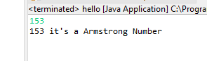**Output:**

1. **import** java.util.Scanner;

**public** **class** hello {

**public** **static** **void** main(String[] args) {

// **TODO** Auto-generated method stub

**for**(**int** i=100;i<=999;i++)

{

**int** temp=i;

**int** sum =0;

**while**(temp>0)

{

**int** rem = temp%10;

sum+= Math.*pow*(rem,3);

temp/=10;

}

**if**(i==sum)

{

System.***out***.println(i);

}

}

}

}

**Output:**

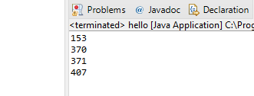

1. **import** java.util.Scanner;

**public** **class** hello {

**public** **static** **void** main(String[] args) {

// **TODO** Auto-generated method stub

**int** principal=5000;

**int** rate = 5;

**int** Time = 10;

;

**int** SI=0;

**double** CI=0;

SI= (principal * rate * Time)/100;

System.***out***.println("SI is : "+ SI);

**int** n = 12;

**double** t=0.05;

CI = Math.*pow*(1+ (t/n),n*Time) * principal;

System.***out***.println("CI is : "+ CI);

}

}

**Output:**

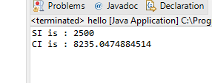

1. **import** java.util.Scanner;

**public** **class** hello {

**public** **static** **void** main(String[] args) {

// **TODO** Auto-generated method stub

Scanner sc = **new** Scanner(System.***in***);

**int** a = sc.nextInt();

**int** b = sc.nextInt();

**int** c = sc.nextInt();

**if**(a>60 && b>60 && c>60)

{

System.***out***.print("Passed");

}

**else** **if**(a> 60 && b>60 && c<60 || a> 60 && b<60 && c>60 || a<60 && b>60 && c>60 )

{

System.***out***.print("Promoted");

}

**else**

{

System.***out***.print("Failed");

}

}

}

**Output:**

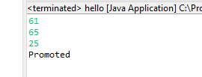

1. **import** java.util.Scanner;

**public** **class** hello {

**public** **static** **void** main(String[] args) {

// **TODO** Auto-generated method stub

Scanner sc = **new** Scanner(System.***in***);

**int** n = sc.nextInt();

**double** tax =0;

**if**(n>=0 && n<=180000)

{

System.***out***.print("Nil");

}

**else** **if**(n>=181001 && n<=300000)

{

tax = (n * 0.1);

System.***out***.print(tax);

}

**else** **if**(n>=300001 && n<=500000)

{

tax = (n * 0.2);

System.***out***.print(tax);

}

**else**

{

tax = (n * 0.3);

System.***out***.print(tax);

}

}

}

**Output:**

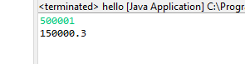

1. **import** java.util.Scanner;

**public** **class** hello {

**public** **static** **void** main(String[] args) {

Scanner sc= **new** Scanner(System.***in***);

String name = **null** ;

**int** flag =0;

**for**(**int** i=0;i<3;i++)

{

System.***out***.println("Enter Login Name: ");

name = sc.nextLine();

System.***out***.println("Enter Password: ");

String pass = sc.nextLine();

**if**(!name.isEmpty() && !pass.isEmpty())

{

flag =1;

**break**;

}

}

**if** (flag==1)

{

System.***out***.println("Welcome, "+name);

}**else**

{

System.***out***.println("Contact Admin");

}

}

}

**Output:**

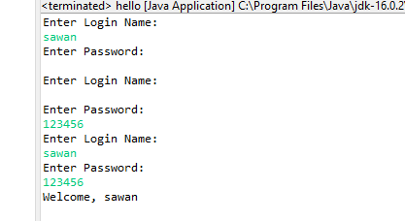

**7. import** java.util.Scanner;

**public** **class** hello {

**public** **static** **void** main(String[] args) {

// **TODO** Auto-generated method stub

Scanner sc = **new** Scanner(System.***in***);

**int** n = sc.nextInt();

**int** arr[]= **new** **int**[n];

**for**(**int** i=0;i<n;i++)

{

arr[i]= sc.nextInt();

}

**int** search =sc.nextInt();

**int** flag =0;

**for**(**int** i=0;i<n;i++)

{

**if**(arr[i]==search)

{

System.***out***.print("Yes "+search +" is present in the array" );

flag =1;

}

}

**if**(flag == 0)

{

System.***out***.print("Yes "+search +" is not present in the array" );

}

}

}

**Output:**

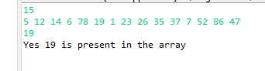

**8. import** java.util.Scanner;

**public** **class** hello {

**public** **static** **void** main(String[] args) {

// **TODO** Auto-generated method stub

Scanner sc = **new** Scanner(System.***in***);

**int** n = sc.nextInt();

**int** arr[]= **new** **int**[n];

**for**(**int** i=0;i<n;i++)

{

arr[i]= sc.nextInt();

}

**int** c =1;

**while**(c<n)

{

**for**(**int** i=0;i<n-c;i++)

{

**if**(arr[i+1]<arr[i])

{

**int** temp = arr[i+1];

arr[i+1]= arr[i];

arr[i]= temp;

}

}

c++;

}

**for**(**int** i=0;i<n;i++)

{

System.***out***.print(arr[i]+" ");

}

}

}

**Output:**

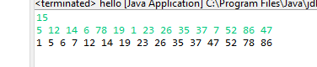

**9.**

**import** java.util.*;

**public** **class** hello {

**public** **static** **void** main(String[] args) {

Scanner s=**new** Scanner(System.***in***);

System.***out***.println("Enter the marks of student 'A':");

System.***out***.println("Maths:");

**int** a=s.nextInt();

System.***out***.println("Science:");

**int** b=s.nextInt();

System.***out***.println("English:");

**int** c=s.nextInt();

System.***out***.println("Enter the marks of student'B':");

System.***out***.println("Maths:");

**int** d=s.nextInt();

System.***out***.println("Science:");

**int** e=s.nextInt();

System.***out***.println("English:");

**int** f=s.nextInt();

System.***out***.println("Enter the marks of student'C':");

System.***out***.println("Maths:");

**int** g=s.nextInt();

System.***out***.println("Science:");

**int** h=s.nextInt();

System.***out***.println("English:");

**int** i=s.nextInt();

System.***out***.println("Total marks of student 'A':"+(a+b+c));

System.***out***.println("Average marks of student 'A':"+((a+b+c)/3));

System.***out***.println("Total marks of student 'B':"+(d+e+f));

System.***out***.println("Average marks of student 'B':"+((d+e+f)/3));

System.***out***.println("Total marks of student 'C':"+(g+h+i));

System.***out***.println("Average marks of student 'C':"+((g+h+i)/3));

System.***out***.println("Total marks of subject 'Maths':"+(a+d+g));

System.***out***.println("Average marks of subject 'Maths':"+((a+d+g)/3));

System.***out***.println("Total marks of subject 'Science':"+(b+e+h));

System.***out***.println("Average marks of subject 'Science':"+((b+e+h)/3));

System.***out***.println("Total marks of subject 'English':"+(c+f+i));

System.***out***.println("Average marks of subject 'English':"+((c+f+i)/3));

}

}

**Output:**

